As we already know what is column standardization.

Basically we subtract mean of the feature from its and element and divide it by its standard deviation.

Subtracting the mean is called as “**Centering”**  and dividing std. deviation is called as ‘**Scaling”**.

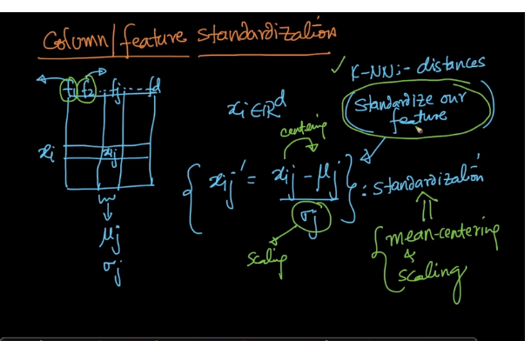

So in logistic regression also it is compulsory to perform feature standardization before training on your D.

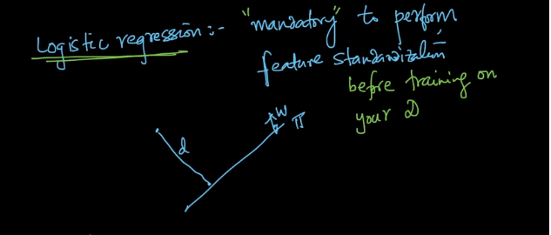

Comments:

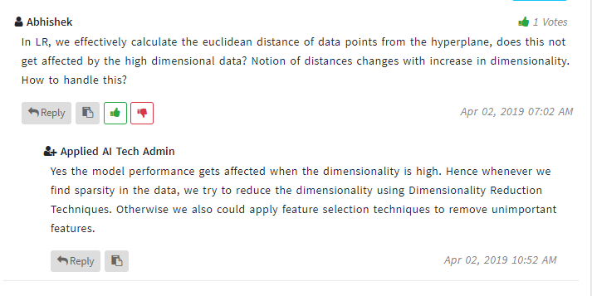

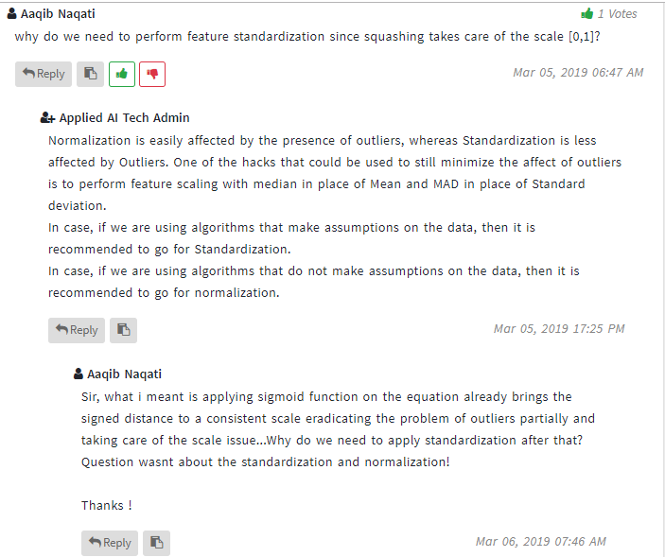

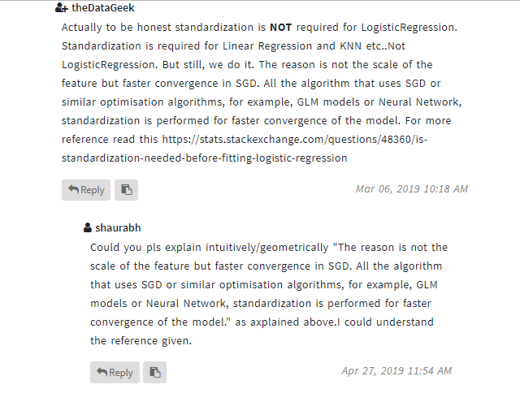

**pto**

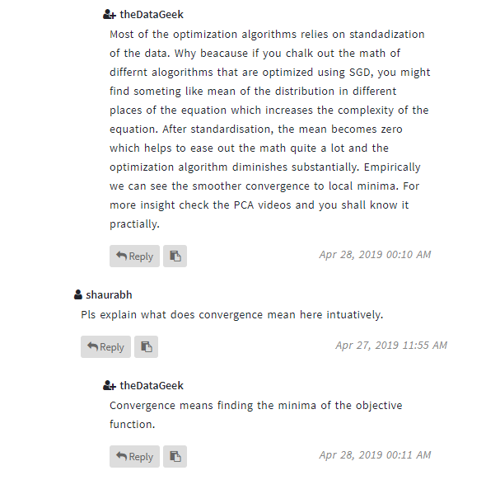

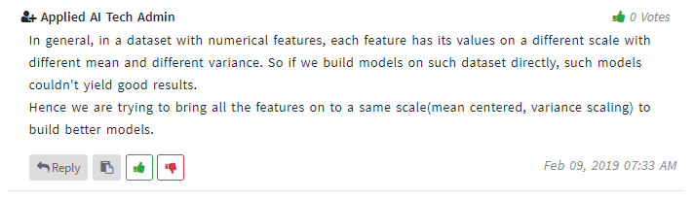

**Where standardization is imp and where isn’t?**

